**Consumers biases in the perception of organizational greed**

**Supplementary Material: Statistical Outputs**

1. **Pretest**
   1. **Normality testing**
      1. **Density plots**

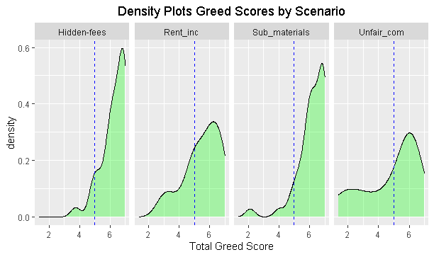

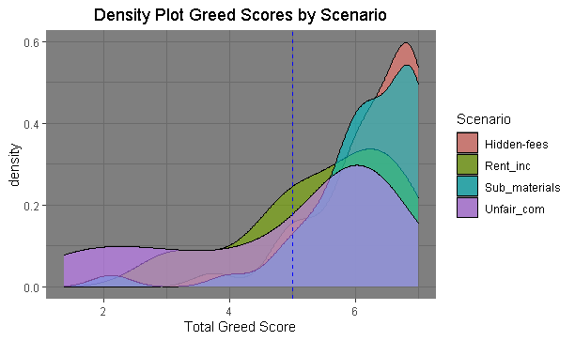

* + 1. **Q-Plot**

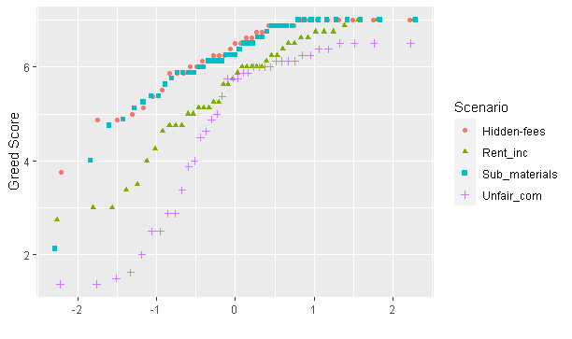

* + 1. **Shapiro-Wilk Test**

Shapiro-Wilk Scores Per Group

Scenario W P.value

Hidden-fees 0.855940 2.172521e-04

Sub_materials 0.797006 2.045124e-06

Rent_inc 0.920218 6.146394e-03

Unfair_com 0.821954 3.022747e-05

* 1. **Mean Differences**

Descriptives

Descriptives per group

$`Hidden-fees`

Min. 1st Qu. Median Mean 3rd Qu. Max.

3.750 5.875 6.500 6.260 6.875 7.000

$Rent_inc

Min. 1st Qu. Median Mean 3rd Qu. Max.

2.750 4.812 5.812 5.497 6.469 7.000

$Sub_materials

Min. 1st Qu. Median Mean 3rd Qu. Max.

2.125 5.875 6.250 6.161 6.875 7.000

$Unfair_com

Min. 1st Qu. Median Mean 3rd Qu. Max.

1.375 3.500 5.750 4.816 6.125 6.500

* + 1. **Plots**

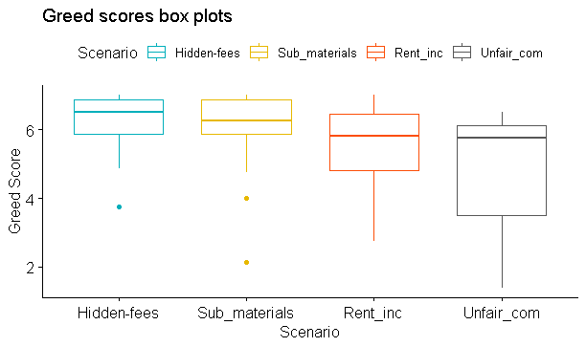

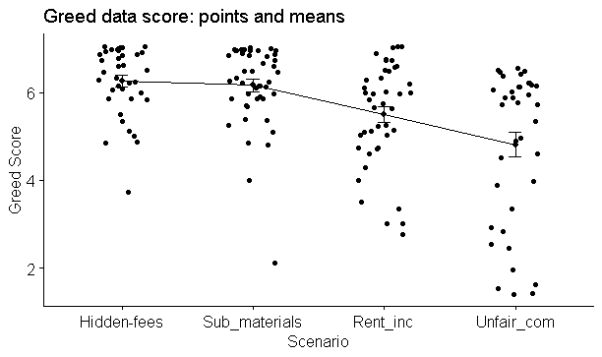

* + 1. **Kruskas Wallis**

Kruskal-Wallis rank sum test

data: Greed_Score by Scenario

Kruskal-Wallis chi-squared = 28.73, df = 3, p-value = 2.552e-06

* + 1. **Post-hoc: Dunn’s Test**

**Comparison Z P.unadj P.adj**

Hidden-fees - Rent_inc 3.1020371 1.921939e-03 3.843877e-03

Hidden-fees - Sub_materials 0.3687707 7.122987e-01 7.122987e-01

Rent_inc - Sub_materials -2.8784742 3.996040e-03 5.994060e-03

Hidden-fees - Unfair_com 4.4347013 9.220002e-06 5.532001e-05

Rent_inc - Unfair_com 1.4508504 1.468215e-01 1.761858e-01

Sub_materials - Unfair_com 4.2775567 1.889558e-05 5.668675e-05

1. **Study 1**
   1. **Preliminary CFA: Questionnaire Validity and Reliability**
      1. **Multivariate normality (for greed)**
         1. **Henze-Zirkler test.**

$multivariateNormality

Test HZ p value MVN

1 Henze-Zirkler 41.35528 0 NO

$univariateNormality

Test Variable Statistic p value Normality

1 Anderson-Darling Dir1 61.5129 <0.001 NO

2 Anderson-Darling Dir2 57.9632 <0.001 NO

3 Anderson-Darling Dir3 50.2573 <0.001 NO

4 Anderson-Darling Dir4 72.1320 <0.001 NO

5 Anderson-Darling Ind1 79.8461 <0.001 NO

6 Anderson-Darling Ind2 74.3423 <0.001 NO

7 Anderson-Darling Ind3 35.0848 <0.001 NO

8 Anderson-Darling Ind4 49.3167 <0.001 NO

* + - 1. **QQ plot**

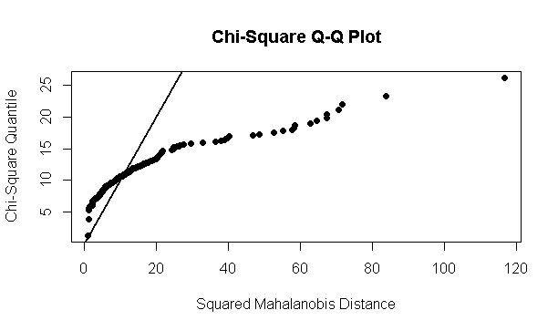

* + 1. **CFA model Summary (fit indices, validity and reliability values).**
       1. **Model Summary**

lavaan 0.6-10 ended normally after 60 iterations

Estimator ML

Optimization method NLMINB

Number of model parameters 53

Number of observations 496

Model Test User Model:

Standard Robust

Test Statistic 410.932 216.924

Degrees of freedom 137 137

P-value (Chi-square) 0.000 0.000

Scaling correction factor 1.894

Satorra-Bentler correction

Model Test Baseline Model:

Test statistic 4354.445 1868.484

Degrees of freedom 171 171

P-value 0.000 0.000

Scaling correction factor 2.330

User Model versus Baseline Model:

Comparative Fit Index (CFI) 0.935 0.953

Tucker-Lewis Index (TLI) 0.918 0.941

Robust Comparative Fit Index (CFI) 0.962

Robust Tucker-Lewis Index (TLI) 0.952

Loglikelihood and Information Criteria:

Loglikelihood user model (H0) -11851.019 -11851.019

Loglikelihood unrestricted model (H1) -11645.553 -11645.553

Akaike (AIC) 23808.037 23808.037

Bayesian (BIC) 24030.986 24030.986

Sample-size adjusted Bayesian (BIC) 23862.762 23862.762

Root Mean Square Error of Approximation:

RMSEA 0.063 0.034

90 Percent confidence interval - lower 0.056 0.028

90 Percent confidence interval - upper 0.071 0.040

P-value RMSEA <= 0.05 0.001 1.000

Robust RMSEA 0.047

90 Percent confidence interval - lower 0.035

90 Percent confidence interval - upper 0.059

Standardized Root Mean Square Residual:

SRMR 0.041 0.041

Parameter Estimates:

Standard errors Robust.sem

Information Expected

Information saturated (h1) model Structured

Latent Variables:

Estimate Std.Err z-value P(>|z|) Std.lv Std.all

Greed =~

Dir1 1.000 0.598 0.796

Dir2 1.155 0.091 12.638 0.000 0.691 0.794

Dir3 0.737 0.102 7.238 0.000 0.441 0.569

Dir4 1.019 0.125 8.119 0.000 0.609 0.429

Ind1 0.871 0.059 14.740 0.000 0.521 0.710

Ind2 0.915 0.105 8.675 0.000 0.547 0.569

Ind3 1.374 0.111 12.354 0.000 0.821 0.608

Ind4 1.326 0.111 11.894 0.000 0.793 0.719

Equality =~

Eq1 1.000 1.157 0.923

Eq2 0.939 0.067 14.074 0.000 1.086 0.776

Need =~

N1 1.000 0.972 0.669

N2 0.830 0.070 11.781 0.000 0.806 0.812

Equity =~

Des1 1.000 0.750 0.730

Des2 1.256 0.090 14.027 0.000 0.943 0.815

Depriv =~

Dep1 1.000 0.694 0.769

Dep2 1.226 0.106 11.516 0.000 0.851 0.831

Blame =~

Bla1 1.000 0.643 0.529

Bla2 1.147 0.151 7.589 0.000 0.737 0.738

Bla3 1.008 0.144 6.979 0.000 0.648 0.663

Covariances:

Estimate Std.Err z-value P(>|z|) Std.lv Std.all

Greed ~~

Equality 0.386 0.056 6.931 0.000 0.558 0.558

Need 0.492 0.061 8.050 0.000 0.847 0.847

Equity 0.362 0.060 6.088 0.000 0.808 0.808

Depriv 0.309 0.053 5.865 0.000 0.746 0.746

Blame 0.258 0.054 4.797 0.000 0.670 0.670

Equality ~~

Need 0.485 0.073 6.651 0.000 0.431 0.431

Equity 0.564 0.089 6.358 0.000 0.649 0.649

Depriv 0.360 0.054 6.686 0.000 0.449 0.449

Blame 0.331 0.083 3.992 0.000 0.446 0.446

Need ~~

Equity 0.531 0.073 7.292 0.000 0.729 0.729

Depriv 0.504 0.074 6.768 0.000 0.748 0.748

Blame 0.416 0.072 5.754 0.000 0.666 0.666

Equity ~~

Depriv 0.385 0.067 5.763 0.000 0.739 0.739

Blame 0.345 0.081 4.262 0.000 0.716 0.716

Depriv ~~

Blame 0.302 0.057 5.321 0.000 0.678 0.678

Variances:

Estimate Std.Err z-value P(>|z|) Std.lv Std.all

.Dir1 0.207 0.031 6.756 0.000 0.207 0.366

.Dir2 0.280 0.048 5.840 0.000 0.280 0.370

.Dir3 0.405 0.051 7.970 0.000 0.405 0.676

.Dir4 1.643 0.253 6.485 0.000 1.643 0.816

.Ind1 0.266 0.067 4.002 0.000 0.266 0.495

.Ind2 0.624 0.142 4.405 0.000 0.624 0.676

.Ind3 1.148 0.140 8.188 0.000 1.148 0.630

.Ind4 0.586 0.107 5.489 0.000 0.586 0.483

.Eq1 0.234 0.107 2.187 0.029 0.234 0.149

.Eq2 0.777 0.171 4.548 0.000 0.777 0.397

.N1 1.164 0.192 6.068 0.000 1.164 0.552

.N2 0.337 0.079 4.241 0.000 0.337 0.341

.Des1 0.492 0.130 3.775 0.000 0.492 0.466

.Des2 0.448 0.118 3.796 0.000 0.448 0.335

.Dep1 0.333 0.077 4.331 0.000 0.333 0.409

.Dep2 0.325 0.076 4.248 0.000 0.325 0.310

.Bla1 1.065 0.214 4.975 0.000 1.065 0.721

.Bla2 0.455 0.111 4.086 0.000 0.455 0.456

.Bla3 0.535 0.146 3.655 0.000 0.535 0.561

Greed 0.358 0.060 5.911 0.000 1.000 1.000

Equality 1.338 0.169 7.929 0.000 1.000 1.000

Need 0.944 0.131 7.213 0.000 1.000 1.000

Equity 0.563 0.107 5.244 0.000 1.000 1.000

Depriv 0.482 0.092 5.242 0.000 1.000 1.000

Blame 0.413 0.113 3.659 0.000 1.000 1.000

R-Square:

Estimate

Dir1 0.634

Dir2 0.630

Dir3 0.324

Dir4 0.184

Ind1 0.505

Ind2 0.324

Ind3 0.370

Ind4 0.517

Eq1 0.851

Eq2 0.603

N1 0.448

N2 0.659

Des1 0.534

Des2 0.665

Dep1 0.591

Dep2 0.690

Bla1 0.279

Bla2 0.544

Bla3 0.439

Reliability Values

Greed Equality Need Equity Depriv Blame

alpha 0.8222220 0.8318252 0.6722986 0.7433037 0.7759187 0.6636203

omega 0.8301294 0.8326559 0.6781627 0.7530120 0.7839984 0.6666654

omega2 0.8301294 0.8326559 0.6781627 0.7530120 0.7839984 0.6666654

omega3 0.8387320 0.8326557 0.6781626 0.7530118 0.7839975 0.6680051

avevar 0.3882466 0.7134947 0.5151962 0.6069248 0.6470797 0.4009812

* + - 1. **Plots (see next pages: Plot functionalities are not ideal in R, compared to software such as AMOS).**

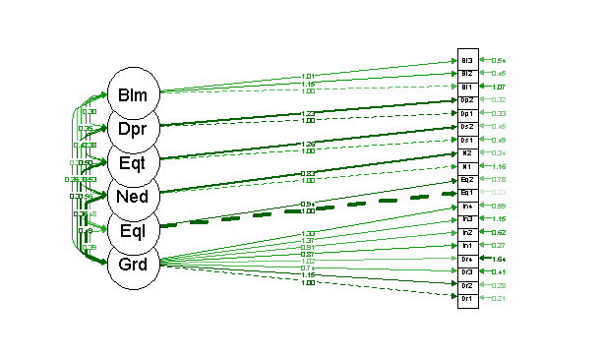

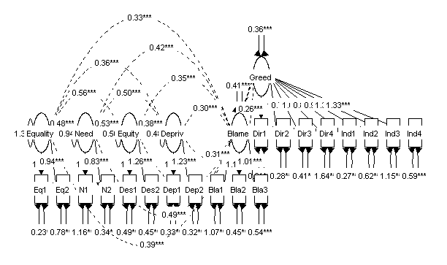

* 1. **Main Analysis (General linear model: ANCOVA).**
     1. **Group Descriptives and Chi-Square Tests**

**Gender**

Small-Local Small-Foreign Large-Local Large-Foreign

Male 53 55 61 69

Female 76 68 61 53

Pearson's Chi-squared test

data: gender

X-squared = 6.7777, df = 3, p-value = 0.07933

**Age**

Small-Local Small-Foreign Large-Local Large-Foreign

18-24 0 9 6 8

25-34 42 43 30 40

35-44 43 33 34 34

45-54 21 18 29 24

55+ 23 20 23 16

Pearson's Chi-squared test

data: age

X-squared = 17.102, df = 12, p-value = 0.1458

**Education**

Small-Local Small-Foreign Large-Local Large-Foreign

Less than high school 1 0 3 0

High School 22 30 31 28

Technical/Diploma 14 18 14 13

University degree 75 62 57 62

Postgraduate 17 13 17 19

Pearson's Chi-squared test

data: education

X-squared = 12.435, df = 12, p-value = 0.4114

**Income**

Small-Local Small-Foreign Large-Local Large-Foreign

Less than 25k 23 31 31 38

25k-<45k 36 38 31 25

45k-<85k 53 41 47 42

85k+ 17 13 13 17

Pearson's Chi-squared test

data: income

X-squared = 9.4976, df = 9, p-value = 0.3927

* + 1. **ANCOVA assumptions**
       1. **Normality**

**Greed Scores Skewed (for reference only: not assumption of ANCOVA)**

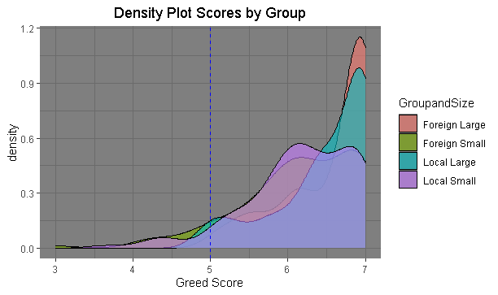

**Normality of residuals plot**

**Histogram**

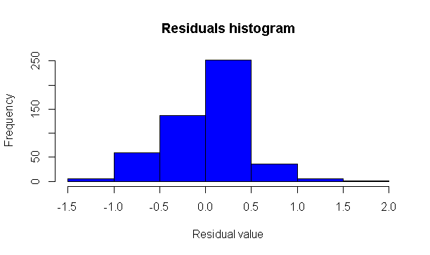

**QQ-Plot**

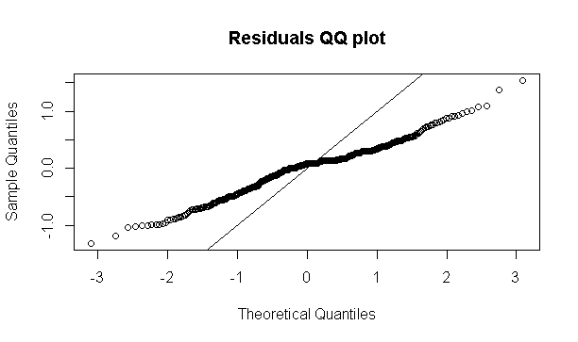

**Shapiro-Wilk**

variable statistic p.value

<chr> <dbl> <dbl>

1 model.metrics$.resid 0.979 0.00000166

* + - 1. **Covariates correlation matrix.**

Equality Need Equity Deprivation Blame

Equality 1.0000000 0.3484629 0.5164137 0.3676890 0.3369462

Need 0.3484629 1.0000000 0.5299498 0.5406528 0.4254201

Equity 0.5164137 0.5299498 1.0000000 0.5659309 0.5195713

Deprivation 0.3676890 0.5406528 0.5659309 1.0000000 0.4848400

Blame 0.3369462 0.4254201 0.5195713 0.4848400 1.0000000

* + - 1. **Homoscedasticity. Homogeneity of variance of residuals between groups.**

df1 df2 statistic p

<int> <int> <dbl> <dbl>

1 3 492 8.35 0.0000200

* + - 1. **Linearity of the relationship between covariates and dependent variable (Greed Scores). Visual method: Plots.**

**Equality and Greed**

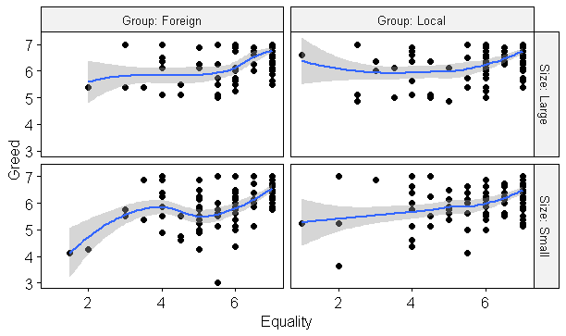

**Need and Greed**

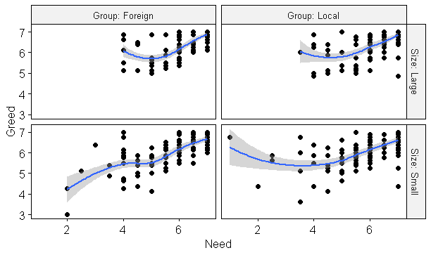

**Equity and Greed**

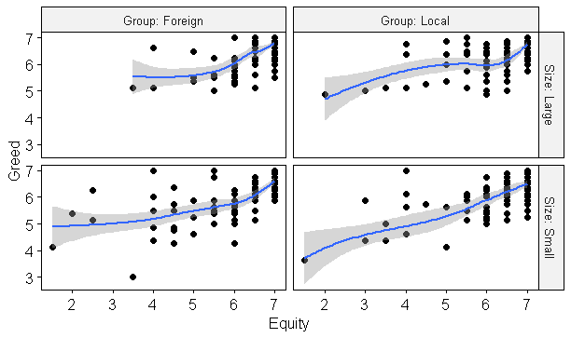

**Deprivation and Greed**

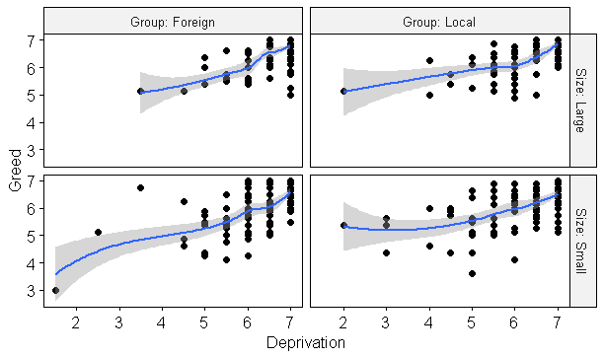

**Blame and Greed**



* + - 1. **Homogeneity of regression slopes**

**Equality**

Effect DFn DFd F p p<.05 ges

1 sizeandgroup 3 488 10.163 1.67e-06 * 0.059

2 Equality 1 488 145.700 1.54e-29 * 0.230

3 sizeandgroup:Equality 3 488 0.687 5.61e-01 0.004

**Need**

Effect DFn DFd F p p<.05 ges

1 sizeandgroup 3 488 4.786 3.00e-03 * 0.029

2 Need 1 488 323.344 7.66e-56 * 0.399

3 sizeandgroup:Need 3 488 2.246 8.20e-02 0.014

**Equity**

Effect DFn DFd F p p<.05 ges

1 sizeandgroup 3 488 8.168 2.58e-05 * 0.048

2 Equity 1 488 328.425 1.66e-56 * 0.402

3 sizeandgroup:Equity 3 488 0.649 5.84e-01 0.004

**Deprivation**

Effect DFn DFd F p p<.05 ges

1 sizeandgroup 3 488 10.853 6.51e-07 * 0.063

2 Deprivation 1 488 307.733 8.91e-54 * 0.387

3 sizeandgroup:Deprivation 3 488 2.458 6.20e-02 0.015

**Blame**

Effect DFn DFd F p p<.05 ges

1 sizeandgroup 3 488 10.163 1.67e-06 * 0.059

2 Equality 1 488 145.700 1.54e-29 * 0.230

3 sizeandgroup:Equality 3 488 0.687 5.61e-01 0.004

* + 1. **General linear model, ANCOVA: 2*2 (Size (Small vs Big) * Group (Local vs Foreign)). Covariates: Equality, Need, Equity, Deprivation, Blame.**

Df Sum Sq Mean Sq F value Pr(>F)

Size 1 14.97 14.97 83.325 < 2e-16 ***

Group 1 0.09 0.09 0.506 0.47734

Equality 1 50.14 50.14 279.126 < 2e-16 ***

Need 1 53.64 53.64 298.638 < 2e-16 ***

Equity 1 15.45 15.45 86.008 < 2e-16 ***

Deprivation 1 8.72 8.72 48.522 1.06e-11 ***

Blame 1 2.46 2.46 13.694 0.00024 ***

Size:Group 1 0.02 0.02 0.086 0.76932

Residuals 487 87.48 0.18

---

Signif. codes: 0 ‘***’ 0.001 ‘**’ 0.01 ‘*’ 0.05 ‘.’ 0.1 ‘ ’ 1

**Etas**

eta.sq eta.sq.part

Size 1.484471e-02 0.0380288124

Group 4.769121e-04 0.0012684289

Equality 1.476853e-02 0.0378410430

Need 5.061220e-02 0.1187740285

Equity 2.075200e-02 0.0523694411

Deprivation 2.825466e-02 0.0699781213

Blame 1.028481e-02 0.0266587803

Size:Group 6.639103e-05 0.0001767713

**Plot**

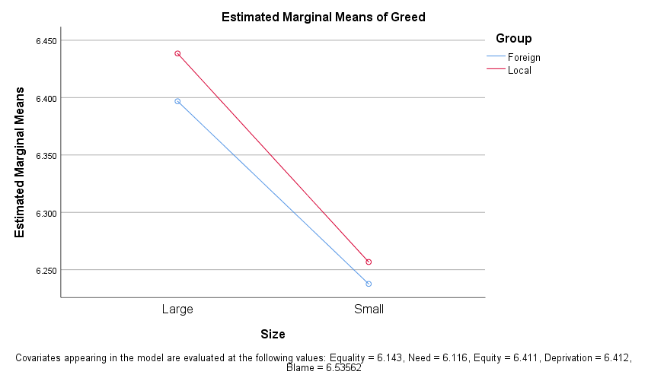

**Robust to rank transformation of the data**

Analysis of Variance of Aligned Rank Transformed Data

Table Type: Anova Table (Type III tests)

Model: No Repeated Measures (lm)

Response: art(Greed)

Df Df.res F value Pr(>F)

1 as.factor(Size) 1 492 36.855301 2.5449e-09 ***

2 as.factor(Group) 1 492 0.159829 0.68949

3 as.factor(Size):as.factor(Group) 1 492 0.013666 0.90699

---

Signif. codes: 0 ‘***’ 0.001 ‘**’ 0.01 ‘*’ 0.05 ‘.’ 0.1 ‘ ’ 1

1. **Study 2**
   1. **Descriptives and Chi Square Tests**

**Gender**

White_S Black_S

Male 47 52

Female 71 59

Pearson's Chi-squared test with Yates' continuity correction

data: gender2

X-squared = 0.87923, df = 1, p-value = 0.3484

**Age**

White_S Black_S

18-24 4 5

25-34 33 38

35-44 31 34

45-54 21 16

55+ 29 18

Pearson's Chi-squared test

data: age2

X-squared = 3.6413, df = 4, p-value = 0.4567

**Education**

White_S Black_S

Less than high school 0 0

High School 26 33

Technical/Diploma 18 11

University degree 59 51

Postgraduate 15 16

Pearson's Chi-squared test

data: education2

X-squared = 2.9229, df = 4, p-value = 0.4036

**Income**

White_S Black_S

Less than 25k 23 27

25k-<45k 37 29

45k-<85k 40 33

85k+ 18 22

Pearson's Chi-squared test

data: income2

X-squared = 2.149, df = 3, p-value = 0.5421

* 1. **Assumptions ANCOVA**
     1. **Normality**

**Greed Scores Skewed (for reference only: not assumption of ANCOVA. AU: White Sheep group, USA: Black Sheep group)**

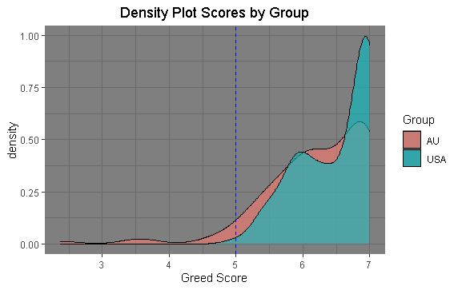

**Normality of residuals**

**Histogram**

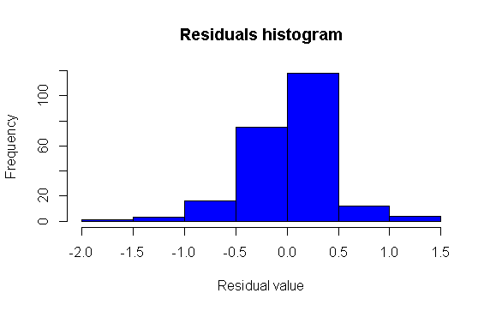

**QQ Plot**

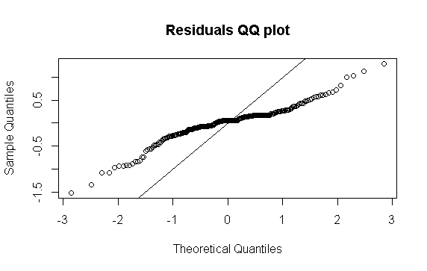

**Shapiro-Wilk**

variable statistic p.value

<chr> <dbl> <dbl>

1 model_metrics$.resid 0.933 0.00000000972

* + 1. **Correlation between covariates.**

Equality Need Equity Deprivation Blame

Equality 1.0000000 0.4950931 0.5403028 0.3524802 0.3815949

Need 0.4950931 1.0000000 0.6185381 0.5719933 0.4883695

Equity 0.5403028 0.6185381 1.0000000 0.6539513 0.6467422

Deprivation 0.3524802 0.5719933 0.6539513 1.0000000 0.5695575

Blame 0.3815949 0.4883695 0.6467422 0.5695575 1.0000000

* + 1. **Homoscedasticity of residuals, Levene’s test.**

df1 df2 statistic p

<int> <int> <dbl> <dbl>

1 1 227 3.57 0.0602

* + 1. **Linearity of relationship between covariates and DV per group.**

**Equality and Greed**

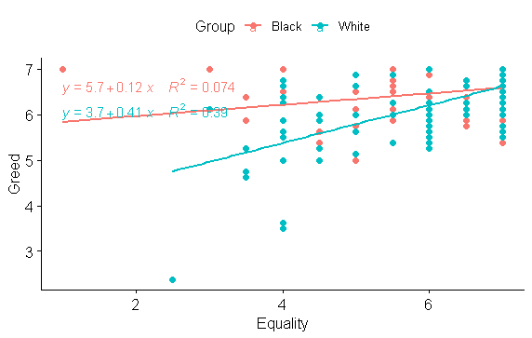

**Need and Greed**

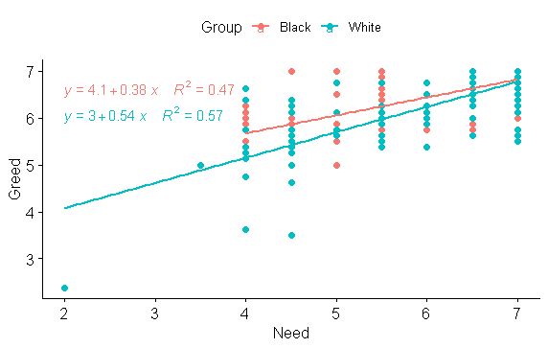

**Equity and Greed**

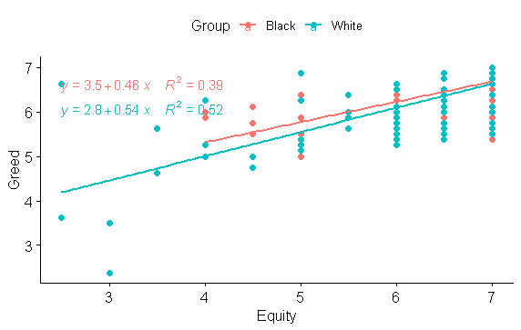

**Deprivation and Greed**

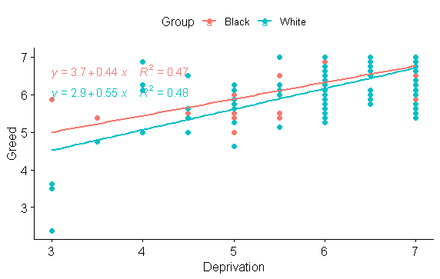

**Blame and Greed**

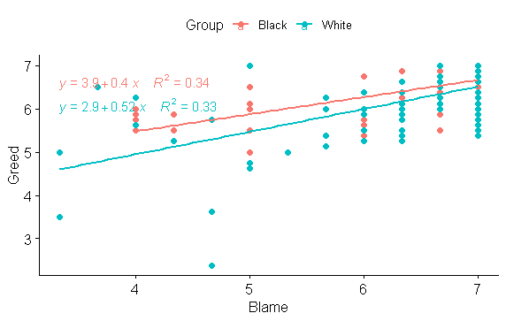

* + 1. **Homogeneity of regression slopes.**

**Equality**

Effect DFn DFd F p p<.05 ges

1 Group 1 225 8.507 4.00e-03 * 0.036

2 Equality 1 225 73.851 1.43e-15 * 0.247

3 Group:Equality 1 225 20.371 1.03e-05 * 0.083

**Need**

Effect DFn DFd F p p<.05 ges

1 Group 1 225 9.570 2.00e-03 * 0.041

2 Need 1 225 258.194 3.29e-39 * 0.534

3 Group:Need 1 225 6.933 9.00e-03 * 0.030

**Equity**

Effect DFn DFd F p p<.05 ges

1 Group 1 225 1.953 1.64e-01 0.009

2 Equity 1 225 210.119 4.56e-34 * 0.483

3 Group:Equity 1 225 1.324 2.51e-01 0.006

**Deprivation**

Effect DFn DFd F p p<.05 ges

1 Group 1 225 4.108 4.40e-02 * 0.018

2 Deprivation 1 225 204.245 2.12e-33 * 0.476

3 Group:Deprivation 1 225 2.187 1.41e-01 0.010

**Blame**

Effect DFn DFd F p p<.05 ges

1 Group 1 225 8.092 5.00e-03 * 0.035

2 Blame 1 225 109.091 4.47e-21 * 0.327

3 Group:Blame 1 225 1.989 1.60e-01 0.009

* 1. **General linear model, One-way ANCOVA (Black_sheep vs White_sheep). Covariates: Equality, Need, Equity, Deprivation, Blame.**

Df Sum Sq Mean Sq F value Pr(>F)

Equality 1 25.58 25.58 165.207 < 2e-16 ***

Need 1 34.38 34.38 222.091 < 2e-16 ***

Equity 1 9.56 9.56 61.731 1.68e-13 ***

Deprivation 1 5.24 5.24 33.829 2.08e-08 ***

Blame 1 0.26 0.26 1.706 0.1929

Group 1 0.72 0.72 4.671 0.0317 *

Residuals 222 34.37 0.15

---

Signif. codes: 0 ‘***’ 0.001 ‘**’ 0.01 ‘*’ 0.05 ‘.’ 0.1 ‘ ’ 1

**Etas**

eta.sq eta.sq.part

Equality 0.002462145 0.007826384

Need 0.072562543 0.188623158

Equity 0.014007117 0.042948118

Deprivation 0.038728388 0.110380786

Blame 0.002994204 0.009501563

Group 0.006567578 0.020607342

**Robust to rank transformation of the data**

Df Df.res F value Pr(>F)

1 as.factor(Group) 1 227 5.8646 0.016234 *

---

Signif. codes: 0 ‘***’ 0.001 ‘**’ 0.01 ‘*’ 0.05 ‘.’ 0.1 ‘ ’ 1

**Plot**

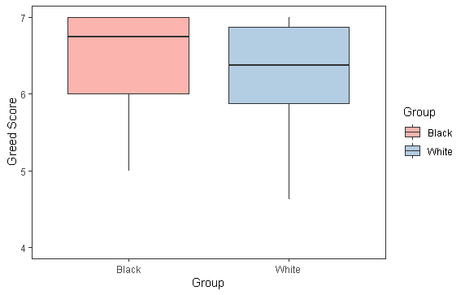

1. **Study 3**
   1. **Descriptives and Chi Square Tests**

**Gender**

Common Uncommon

Male 48 55

Female 77 69

Pearson's Chi-squared test

data: gender3

X-squared = 0.68113, df = 1, p-value = 0.4092

**Age**

Common Uncommon

18-24 3 9

25-34 31 38

35-44 33 28

45-54 32 20

55+ 26 29

Pearson's Chi-squared test

data: age3

X-squared = 7.0489, df = 4, p-value = 0.1333

**Education**

Common Uncommon

Less than high school 1 1

High School 27 30

Technical/Diploma 21 15

University degree 47 58

Postgraduate 29 20

Pearson's Chi-squared test

data: education3

X-squared = 3.9594, df = 4, p-value = 0.4115

**Income**

Common Uncommon

Less than 25k 30 35

25k-<45k 36 39

45k-<85k 41 37

85k+ 18 13

Pearson's Chi-squared test

data: income3

X-squared = 1.5122, df = 3, p-value = 0.6795

* 1. **Assumptions ANCOVA.**
     1. **Normality.**

**Greed Scores Skewed (for reference only: not assumption of ANCOVA.**

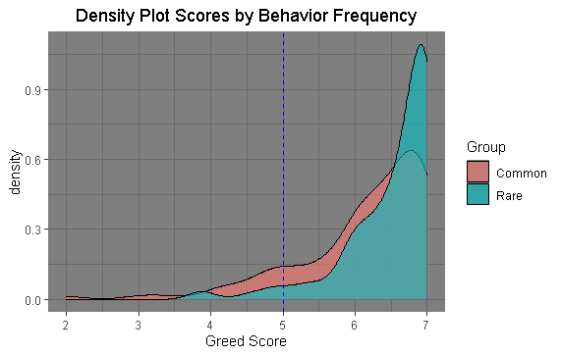

**Normality of residuals**

**Histogram**

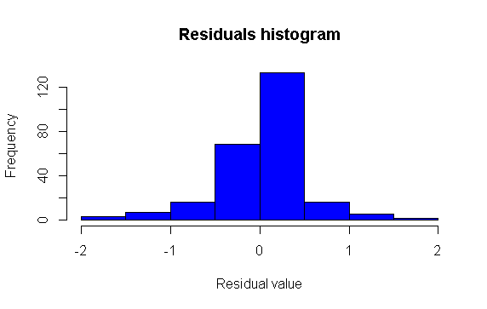

**QQ plot**

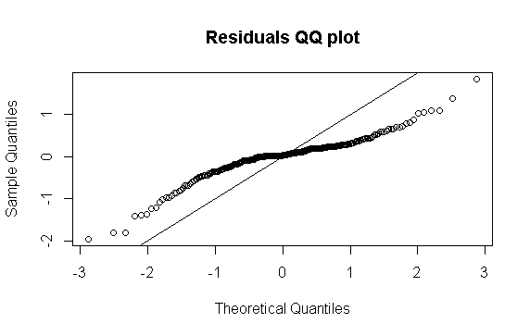

**Shapiro-Wilk**

variable statistic p.value

<chr> <dbl> <dbl>

1 model_metrics3$.resid 0.915 1.01e-10

* + 1. **Correlation between covariates.**

Equality Need Equity Deprivation Blame

Equality 1.0000000 0.4826596 0.6426038 0.4299515 0.3754204

Need 0.4826596 1.0000000 0.5966472 0.5560741 0.4208977

Equity 0.6426038 0.5966472 1.0000000 0.5153777 0.5396162

Deprivation 0.4299515 0.5560741 0.5153777 1.0000000 0.4900813

Blame 0.3754204 0.4208977 0.5396162 0.4900813 1.0000000

* + 1. **Homoscedasticity of residuals, Levene’s test.**

df1 df2 statistic p

<int> <int> <dbl> <dbl>

1 1 247 2.97 0.0861

* + 1. **Linearity of relationship between covariates and DV per group.**

**Equality and Greed**

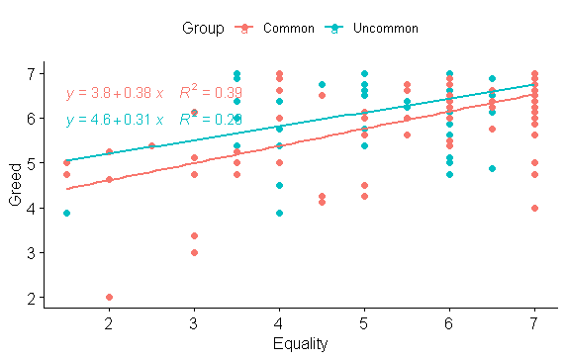

**Need and Greed**

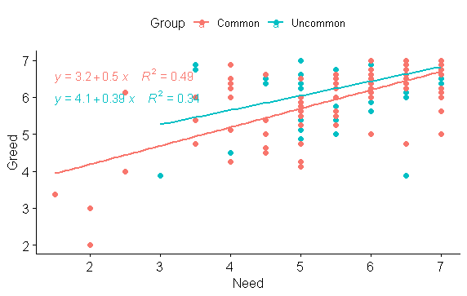

**Equity and Greed**

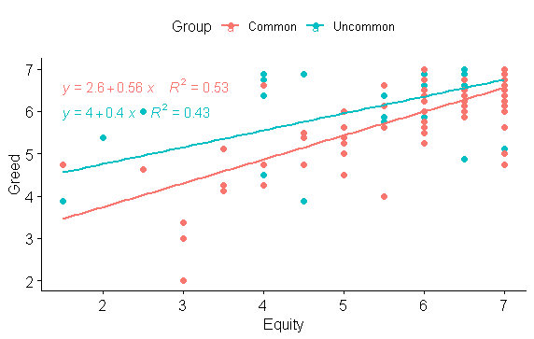

**Deprivation and Greed**

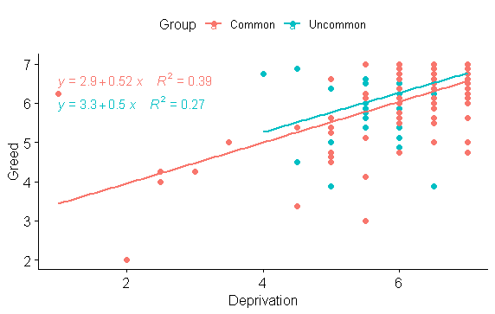

**Blame and Greed**

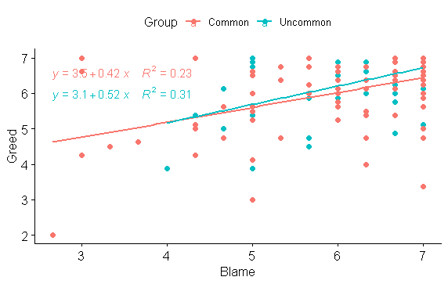

* + 1. **Homogeneity of regression slopes.**

**Equality**

Effect DFn DFd F p p<.05 ges

1 Group 1 245 11.143 9.75e-04 * 0.044

2 Equality 1 245 132.868 7.58e-25 * 0.352

3 Group:Equality 1 245 1.390 2.40e-01 0.006

**Need**

Effect DFn DFd F p p<.05 ges

1 Group 1 245 8.655 4.00e-03 * 0.034

2 Need 1 245 188.411 3.45e-32 * 0.435

3 Group:Need 1 245 2.542 1.12e-01 0.010

**Equity**

Effect DFn DFd F p p<.05 ges

1 Group 1 245 17.486 4.03e-05 * 0.067

2 Equity 1 245 239.058 4.28e-38 * 0.494

3 Group:Equity 1 245 6.584 1.10e-02 * 0.026

**Deprivation**

Effect DFn DFd F p p<.05 ges

1 Group 1 245 6.859 9.00e-03 * 0.027000

2 Deprivation 1 245 131.509 1.18e-24 * 0.349000

3 Group:Deprivation 1 245 0.037 8.47e-01 0.000152

**Blame**

Effect DFn DFd F p p<.05 ges

1 Group 1 245 6.656 1.00e-02 * 0.026

2 Blame 1 245 82.096 4.24e-17 * 0.251

3 Group:Blame 1 245 0.797 3.73e-01 0.003

* + 1. **General linear model, One-way ANCOVA (Common vs Uncommon behavior). Covariates: Equality, Need, Equity, Deprivation, Blame.**

Df Sum Sq Mean Sq F value Pr(>F)

Equality 1 59.00 59.00 248.207 < 2e-16 ***

Need 1 30.69 30.69 129.117 < 2e-16 ***

Equity 1 9.74 9.74 40.965 7.97e-10 ***

Deprivation 1 5.04 5.04 21.209 6.66e-06 ***

Blame 1 1.16 1.16 4.893 0.02790 *

Group 1 1.84 1.84 7.725 0.00588 **

Residuals 242 57.52 0.24

---

Signif. codes: 0 ‘***’ 0.001 ‘**’ 0.01 ‘*’ 0.05 ‘.’ 0.1 ‘ ’ 1

**Etas**

eta.sq eta.sq.part

Equality 0.01583363 0.04344186

Need 0.03873878 0.10000106

Equity 0.03247300 0.08520460

Deprivation 0.01919902 0.05219337

Blame 0.00478300 0.01353317

Group 0.01112866 0.03093241

**Robust to rank transformation of the data**

Analysis of Variance of Aligned Rank Transformed Data

Table Type: Anova Table (Type III tests)

Model: No Repeated Measures (lm)

Response: art(Greed)

Df Df.res F value Pr(>F)

1 as.factor(Group) 1 247 15.553 0.00010453 ***

---

Signif. codes: 0 ‘***’ 0.001 ‘**’ 0.01 ‘*’ 0.05 ‘.’ 0.1 ‘ ’ 1

**Plot**

